HOW TO CREATE A SALES PROCESS TEMPLATE

Sales Pipeline Template

Typically, there are nine stages in the sales pipeline, as outlined below. Review your current business model to determine which of these stages apply to your organization.
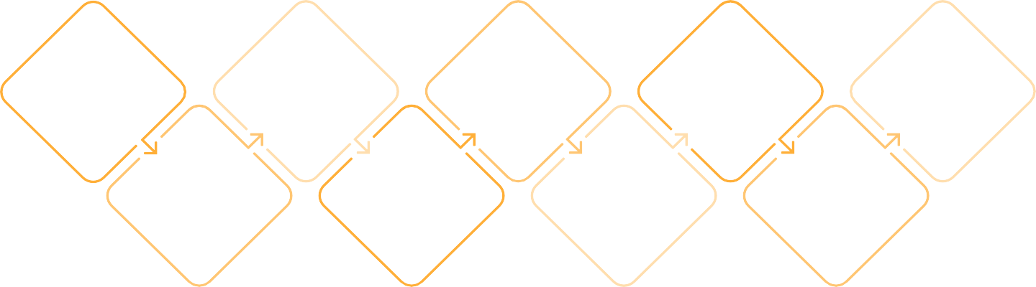
Lead Generation
Lead Qualification
Initial
Contact
Proposal Presentation
Closing
Retention & Upselling
Needs Assessment
Negotiation
Post-Sale Follow-Up

Sales Pipeline Activities Template

Using the stages of your organization’s sales pipeline outlined above, list the activities you typically perform at each stage. Replace the examples below with your own entries.

SALES PIPELINE STAGE | ACTIVITIES
Lead Generation | - Running targeted marketing campaigns (email, social media).  - Attending trade shows or networking events to meet potential clients.  - Creating engaging content (blogs, webinars, podcasts) to attract leads.
Lead Qualification | - Conducting research to gather information on potential leads.  - Using qualification frameworks to evaluate leads.  - Completing a lead scoring system to prioritize leads based on their likelihood to convert.
Initial Contact | - Sending personalized emails to introduce yourself and your product or service.  - Making cold calls to gauge interest and set up meetings.  - Connecting on social media platforms and engaging with leads.
Needs Assessment | - Conducting discovery calls or meetings to ask open-ended questions.  - Listening actively to the prospect’s challenges and goals.  - Sending questionnaires or surveys to gather detailed information.  - Analyzing the prospect’s current processes and pain points to tailor solutions.
Proposal Presentation | - Creating and delivering a customized presentation that addresses the prospect’s needs.  - Drafting a formal proposal that outlines the solution, pricing, and timelines.  - Demonstrating the product or service through a live demo or trial.  - Providing case studies or testimonials to build credibility and trust.
Negotiation | - Discussing terms, pricing, and conditions openly with the prospect.  - Offering flexible solutions or discounts to overcome barriers.  - Holding meetings to ensure all parties understand the agreement.  - Addressing any final objections or concerns the prospect may have.
Closing | - Finalizing contracts or agreements for signatures.  - Providing payment instructions and processing the transaction.  - Conducting a final review of the agreement to ensure mutual understanding.  - Celebrating the win (internally and with the customer) to foster positive relationships.
Post-Sale Follow-Up | - Sending a thank-you note or email to the new customer.  - Scheduling a follow-up call or meeting to ensure satisfaction.  - Providing onboarding resources such as guides or tutorials.  - Conducting a post-purchase survey to gather feedback.
Retention & Upselling | - Establishing regular check-ins or quarterly business reviews with customers.  - Creating loyalty programs or special offers for existing customers.  - Identifying opportunities for upselling based on customer needs and usage.  - Collecting ongoing feedback and making improvements to products/services.

Sales Process Flowchart Template

Visualize your sales process using flowcharts that incorporate different shapes and colors to guide the viewer from start to finish. Ensure that the flowchart reflects both activities that can be completed immediately and those that depend on the completion of prior tasks.

START

1 - PROSPECTING

2 - LEAD QUALIFICATION

NO
Reassess qualification criteria or remove lead from pipeline.

YES

3 - NEEDS ASSESSMENT

8 - RETENTION AND UPSELLING

4 - PROPOSAL PRESENTATION
Did they agree to a purchase?

NO
Ask for specific feedback and adjust the proposal if possible

YES

5 - HANDLING OBJECTIONS

Did they accept?

NO
Ask for feedback

YES

6 - CLOSING

7 - FOLLOW-UP

END

Sales Pipeline Performance Metrics Template

Once you have identified all your pipeline stages and the activities that go with each, list the performance metrics to evaluate the success of each stage. Replace the examples below with your specific entries.

SALES PIPELINE STAGE | ACTIVITIES | PERFORMANCE METRICS
Lead Generation | - Running targeted marketing campaigns (email, social media).  - Attending trade shows or networking events to meet potential clients.  - Creating engaging content (blogs, webinars, podcasts) to attract leads. | - Number of leads generated  - Cost per lead  - Lead source breakdown (which channels are most effective)  - Conversion rate from lead to qualified lead  - Engagement metrics from marketing campaigns (click-through rates, etc.)
Lead Qualification | - Conducting research to gather information on potential leads.  - Using qualification frameworks to evaluate leads.  - Completing a lead scoring system to prioritize leads based on their likelihood to convert. | - Percentage of qualified leads versus total leads  - Average lead score  - Time taken to qualify leads  - Number of leads moved to the next stage  - Qualification rate (the ratio of leads qualified to leads generated)
Initial Contact | - Sending personalized emails to introduce yourself and your product or service.  - Making cold calls to gauge interest and set up meetings.  - Connecting on social media platforms and engaging with leads. | - Number of contacts made (calls/emails)  - Response rate to outreach efforts  - Conversion rate from initial contact to the needs assessment stage  - Average time to first contact  - Number of appointments set
Needs Assessment | - Conducting discovery calls or meetings to ask open-ended questions.  - Listening actively to the prospect’s challenges and goals.  - Sending questionnaires or surveys to gather detailed information.  - Analyzing the prospect’s current processes and pain points to tailor solutions. | - Number of needs assessment calls/meetings conducted  - Conversion rate from needs assessment to proposal stage  - Average duration of needs assessment discussions  - Customer satisfaction feedback scores from the assessment stage
Proposal Presentation | - Creating and delivering a customized presentation that addresses the prospect’s needs.  - Drafting a formal proposal that outlines the solution, pricing, and timelines.  - Demonstrating the product or service through a live demo or trial.  - Providing case studies or testimonials to build credibility and trust. | - Number of proposals sent  - Proposal acceptance rate (percentage accepted vs. sent)  - Average time from proposal sent to acceptance  - Proposal to close ratio (how many proposals resulted in sales)  - Lead feedback scores on presentations or proposals
Negotiation | - Discussing terms, pricing, and conditions openly with the prospect.  - Offering flexible solutions or discounts to overcome barriers.  - Holding meetings to ensure all parties understand the agreement.  - Addressing any final objections or concerns the prospect may have. | - Average duration of negotiations  - Percentage of negotiations that close successfully  - Number of objections raised vs. objections resolved  - Post-negotiation satisfaction score from leads/customers  - Number of deals lost at the negotiation stage
Closing | - Finalizing contracts or agreements for signatures.  - Providing payment instructions and processing the transaction.  - Conducting a final review of the agreement to ensure mutual understanding.  - Celebrating the win (internally and with the customer) to foster positive relationships. | - Closing rate (percentage of deals closed vs. deals in the pipeline)  - Average time to close a deal  - Revenue generated from closed deals  - Percentage of sales forecasts met  - Customer satisfaction with the closing process
Post-Sale Follow-Up | - Sending a thank-you note or email to the new customer.  - Scheduling a follow-up call or meeting to ensure satisfaction.  - Providing onboarding resources such as guides or tutorials.  - Conducting a post-purchase survey to gather feedback. | - Follow-up completion rate (percentage of customers followed up with)  - Customer satisfaction ratings post-sale  - Number of issues resolved during follow-up  - Time taken for follow-up after the sale  - Retention rate of new customers
Retention & Upselling | - Establishing regular check-ins or quarterly business reviews with customers.  - Creating loyalty programs or special offers for existing customers.  - Identifying opportunities for upselling based on customer needs and usage.  - Collecting ongoing feedback and making improvements to products/services. | - Customer retention rate  - Number of upsell opportunities identified  - Upsell conversion rate (number of upsells sold vs. opportunities)  - Net Promoter Score or Customer Satisfaction Score from retained customers

